‘German-American School of
Ft. Lauderdale’
www.germanschoolfl.com
germanschoolfl@aol.com
Tel.: 954- 391-9847
‘Lernen mit Kopf, Herz und Hand’

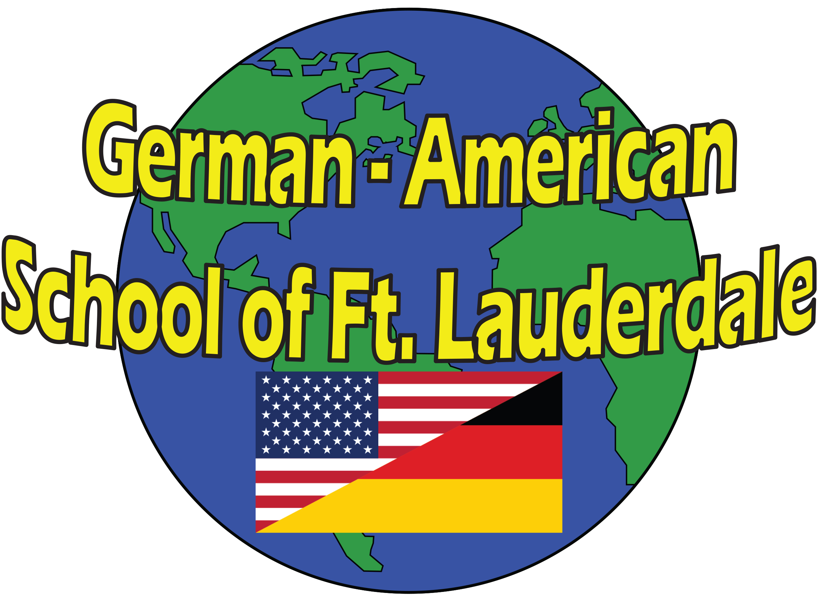
“Full Immersion German Summer Camp 2020”

In these summer programs children ages 1-9 years, experience the German language and culture in a peaceful, quiet and fun environment.
The teaching principles of ‘Learning With Your Head, Heart, and Hands’ like those of ‘Learning With All Your Senses’ play a particularly important role. The curriculum offers projects with ‘hands on activities’ as well as group interaction during circle, music, art, story time, puppet shows and outdoor activities.
Dates: Weekly, or monthly Sessions from June 3rd – August 16th 2019.
Location: German-American School of Ft. Lauderdale
4200 N. 65th Avenue, Davie, Fl. 33024
Prices: One time $ 80.00 registration & material fee for all sessions

Prices weekly | - child | - child | - child
German 8:30a.m. – 1:00p.m. | $180.00 | $170.00 | $160.00
German 8:30a.m. – 3:00 p.m. | $ 210.00 | $ 200.00 | $ 190.00
German 8:30a.m. – 6:00 p.m. | $ 255.00 | $245.00 | $ 225.00
German After care/hourly rate | $9.50 / h | $8.50 / h | $7.50 / h

Prices monthly | - child | - child | - child
German 8:30a.m. – 1:00p.m. | $590.00 | $550.00 | $500.00
German 8:30a.m. – 3:00 p.m. | $ 750.00 | $ 680.00 | $ 610.00
German 8:30a.m. – 6:00 p.m. | $ 900.00 | $800.00 | $ 730.00

Please sign up soon, spaces are limited. Before and after care available.
Please indicate the weeks / months child(ren) will be attending.
To register, please fill out the registration form and send it back together with the registration - & material fee to the address above.
Please have children bring a snack & lunch!

